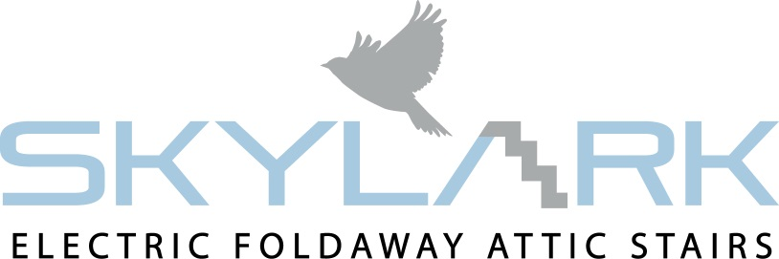

Operational & Safety Instructions
Guide to safely using your Skylark Electric Attic Stairs

- Always stand well clear of trap door when it’s opening and closing.

- Before opening your Skylark ensure no one is standing under the opening as they may be hit by the stairs as you open it.

- While opening the Skylark insure the operator has enough room to operate the stairs.

- Never stand on or touch the stairs until it comes to the floor and to a full stop.

- As the stairs is being operated you can stop it at any time by letting go of the button, the stairs will come to a full stop right away. However when the stairs is closing it is best practice to let it close fully without stopping it, as it will put the motors under extra strain.

- Never tamper with any cables or fixed parts.

- Make sure that the remote control is kept in a safe convenient place out of reach of children.

- The stairs should never be closed while someone is in the loft. Closing the stairs while someone is in the loft causes a serious safety concern as the person in the loft is trapped in the event of emergency.

- Never take your eyes off the stairs while it is being operated!

- While the stairs is being opened the operator should always watch the stairs and its surroundings to prevent accidents. I.E. someone could walk out of a room and not notice the stairs opening and cause an accident. It is the operator’s duty to keep others safe while the stairs is in use.

- Always face the ladder when climbing up and coming down from the loft. Facing the ladder gives the best footing and makes it easier to hold onto your handrail.

- Do not hold onto metal parts other than the handrail when using the Skylark stairs as it could result in damaging the part and preventing the stairs from closing.

- Keep the area around the trapdoor opening in the attic clean and clear so there are no obstructions around the stairs which could either prevent the operator from entering the attic or could fall onto the stairs obstructing its operation.

- Never allow children or someone who has not read the safety and operational instructions for the Skylark Stairs to operate it.

BS EN 14975 Standard

